HARDWARE IMPLEMENTATION

4.1 CIRCUIT DIAGRAM:

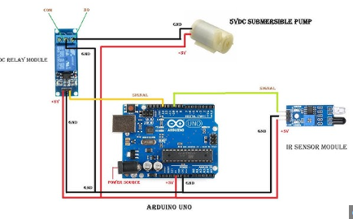

The entire system requires a stable, low-voltage direct current (DC) to operate safely near water.A standard 12V power adapter or battery steps down the mains voltage. An integrated voltage regulator, such as the LM7805, is typically used to drop this down to a steady 5V for the electronic sensor module.The sensing unit serves as the "eyes" of the circuit. It is built using two primary optical components .IR Transmitter (LED): This component continuously emits a beam of invisible infrared light straight ahead or downward. IR Receiver (Photodiode): This component waits to detect any reflected light. Under normal conditions (no hands present), the emitted light scatters and the receiver detects nothing.
Comparator/Op-Amp: When you place your hand under the tap, the infrared light bounces off your skin and hits the receiver. An onboard comparator (like the LM358) measures this change in voltage and flips the sensor's output signal . Because the IR sensor operates on weak logic-level signals (around 5V), it cannot directly power the valve. A switching mechanism is required to bridge the small sensor signal with the higher-power valve circuit. Transistor/Relay Driver: The output of the IR sensor is connected to the base (input) of a switching transistor (like a TIP122) or a relay module. Relay: When the sensor detects a

hand, the transistor turns ON, which energizes the electromagnetic coil in the relay. The relay acts as a mechanical bridge, closing the high-power circuit connected to the water valve
The solenoid valve acts as the automatic, electrically controlled "tap" that regulates the water. When the relay closes the circuit, a 12V DC supply is delivered to the solenoid valve.The solenoid creates an electromagnetic field that lifts an internal plunger, opening the water pathway. Water flows freely out of the faucet. When you remove your hand, the IR sensor stops detecting the reflection. The comparator circuit cuts the power to the relay, the electromagnet deactivates, and a heavy-duty internal spring forces the valve shut, instantly stopping .Protection Diode flyback diode (such as the 1N4007) is placed across the relay coil to safely dissipate any reverse voltage spikes when the relay turns off, protecting the delicate sensor and transistor from damage.

FLOW CHART:

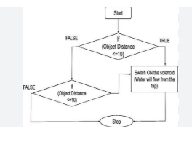

1. System Initialization
The system powers on. The microcontroller initializes its input pins (connected to the IR receiver) and output pins (connected to the solenoid valve). The solenoid valve defaults to the CLOSED position to prevent water leakage.
2. Continuous IR Emission
The IR transmitter constantly emits an infrared beam into the area directly beneath the tap spout.
3. Object Detection (Decision Point)
The system continuously monitors the IR receiver for a signal reflection
- Scenario A (No hands present): The emitted IR light travels into empty space and does not bounce back. The receiver detects nothing. The system loops back to the start and continues monitoring.

- Scenario B (Hands present): When a user places their hands under the tap, the hands interrupt the beam. The IR light bounces off the hands and reflects directly into the IR receiver.

4. Signal Processing
The IR receiver detects the reflected light and converts this light energy into an electrical signal. It sends a "HIGH" voltage signal to the microcontroller or control circuit, indicating that an object is nearby.

5. Activating Water Flow
Upon receiving the presence signal, the microcontroller sends an electric current to the solenoid valve. This current creates a magnetic field inside the valve, pulling the internal plunger open. Water flows through the tap.

6. Continuous Verification Loop
While water is running, the IR sensor keeps checking for the presence of the hands.
- As long as the hands remain under the tap, the receiver keeps getting reflected light. The valve stays OPEN.

7. Deactivation and Reset
When the user removes their hands, the IR light is no longer reflected back to the receiver.

- The receiver signal drops to "LOW".
- The microcontroller stops sending electric current to the solenoid valve.
- A spring inside the valve pushes the plunger back down, instantly cutting off the water flow.
- The system returns to Step 2, waiting for the next user.

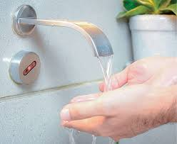

CODE:

int ir=3;
int rly=2;
void setup() {
pinMode(ir,INPUT);
pinMode(rly,OUTPUT);
digitalWrite(rly,1);
Serial.begin(9600);

}

void loop() {
int ival=digitalRead(ir);
Serial.println(ival);
if (ival==0){
digitalWrite(rly,0);
}

else {

digitalWrite(rly,1);

}

}

